**1&2. CREATING DATABASE AND TABLES3.INSTERTING CUSTOMER ACCOUNT VALUES3.INSERTING BANK BRANCH VALUES**

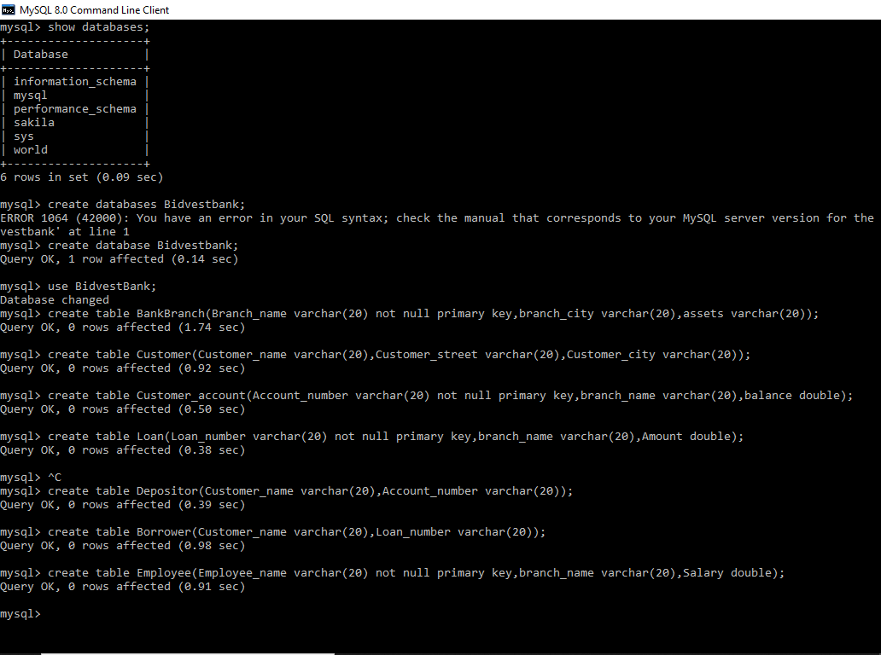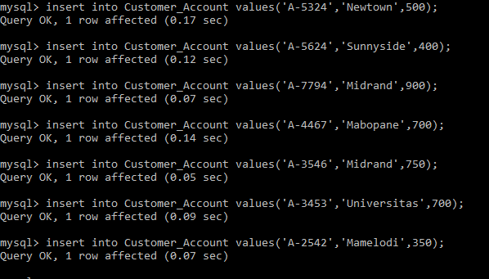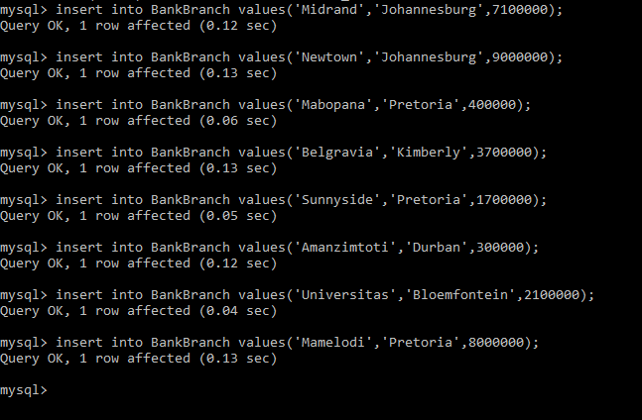

**4.INSERTING CUSTOMER,BORROWER, LOAN AND EMPLOYEE VALUES**

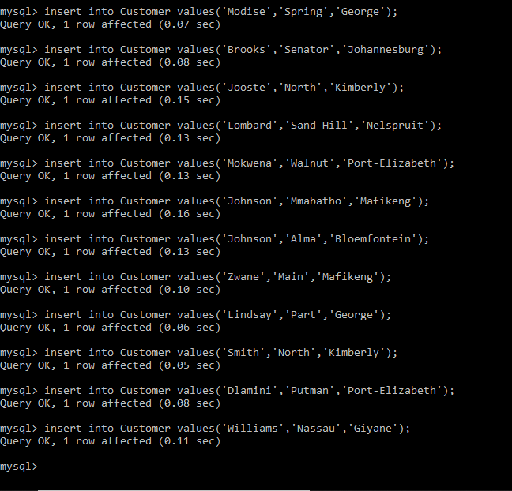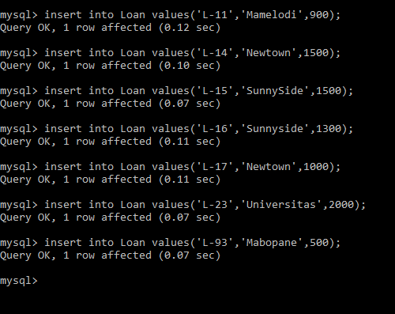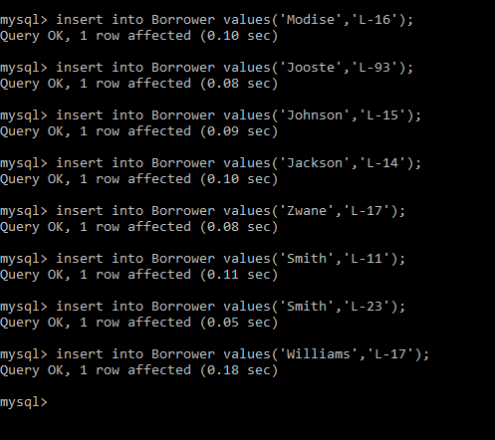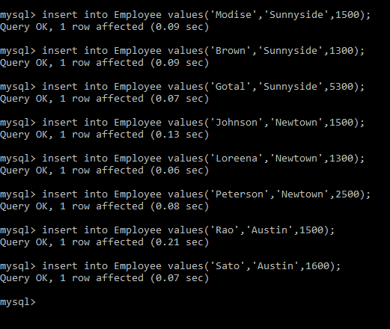

**4 i) CUSTOMER ACCOUNT WHERE BALANCE IS LESS THAN 700**

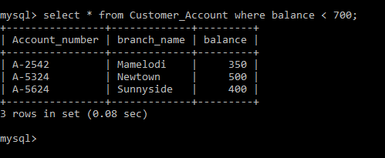

**ii) CUSTOMER WHERE CUSTOMER CITY IS JOHANNESBURG**.**iii ) Employees whose salary is greater than R1500 and working branch is not Newtown.**

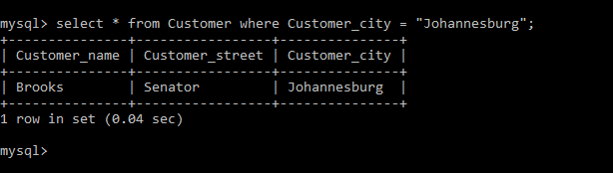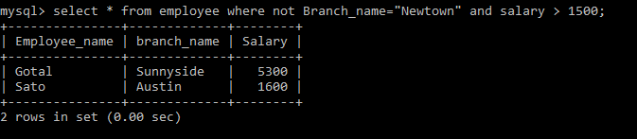

**iv) Calculate the average salary of all employees and show the average salary as “avg_salary”**

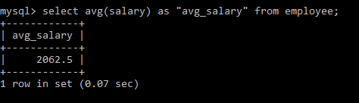

**V) The bank with the largest number of Assets.**

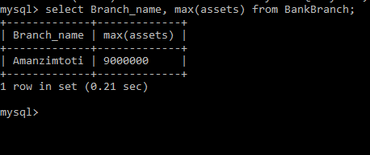

**5. Provide the SQL code which can utilize BidvestBank database to provide the following:**

